Template Project Management Plan

# Introduction

The aim of this project is to produce a detailed design report for a convertible Fiat 595 Abarth that puts itself in direct competition with the BMW Mini Cooper convertible. Acting as the engineering team at Abarth, the following report presents a ‘proof-of-concept design’ for the Fiat with the goal of taking the idea forward into detailing and production based on the concept’s viability for a convertible 595 Abarth.

# Project scope

**Scope of project (Work Breakdown Structure):**

* Market research, stakeholders, and priorities with a PDS.
* Concept selection using FBDs, Lego, and Linkage + CAD design.
* Modelling: motor and gear ratio combinations, system damping, gearbox efficiency, COM, mechanical power, power vs torque graph, radius vs angle of mechanism graph, angle vs time for retracting/deploying mechanism graph, mechanical power vs time.
* Manufacturing planning of chosen component + technical CAD drawing.
* Material selection and costing of all materials intended to use.
* Mechatronics report on chosen safety features and their respective sensors for the convertible roof mechanism.
* Motor and gear combination choices + CAD design of gearbox.
* Design evaluation of success of entire proposed report highlighting successes and failures.

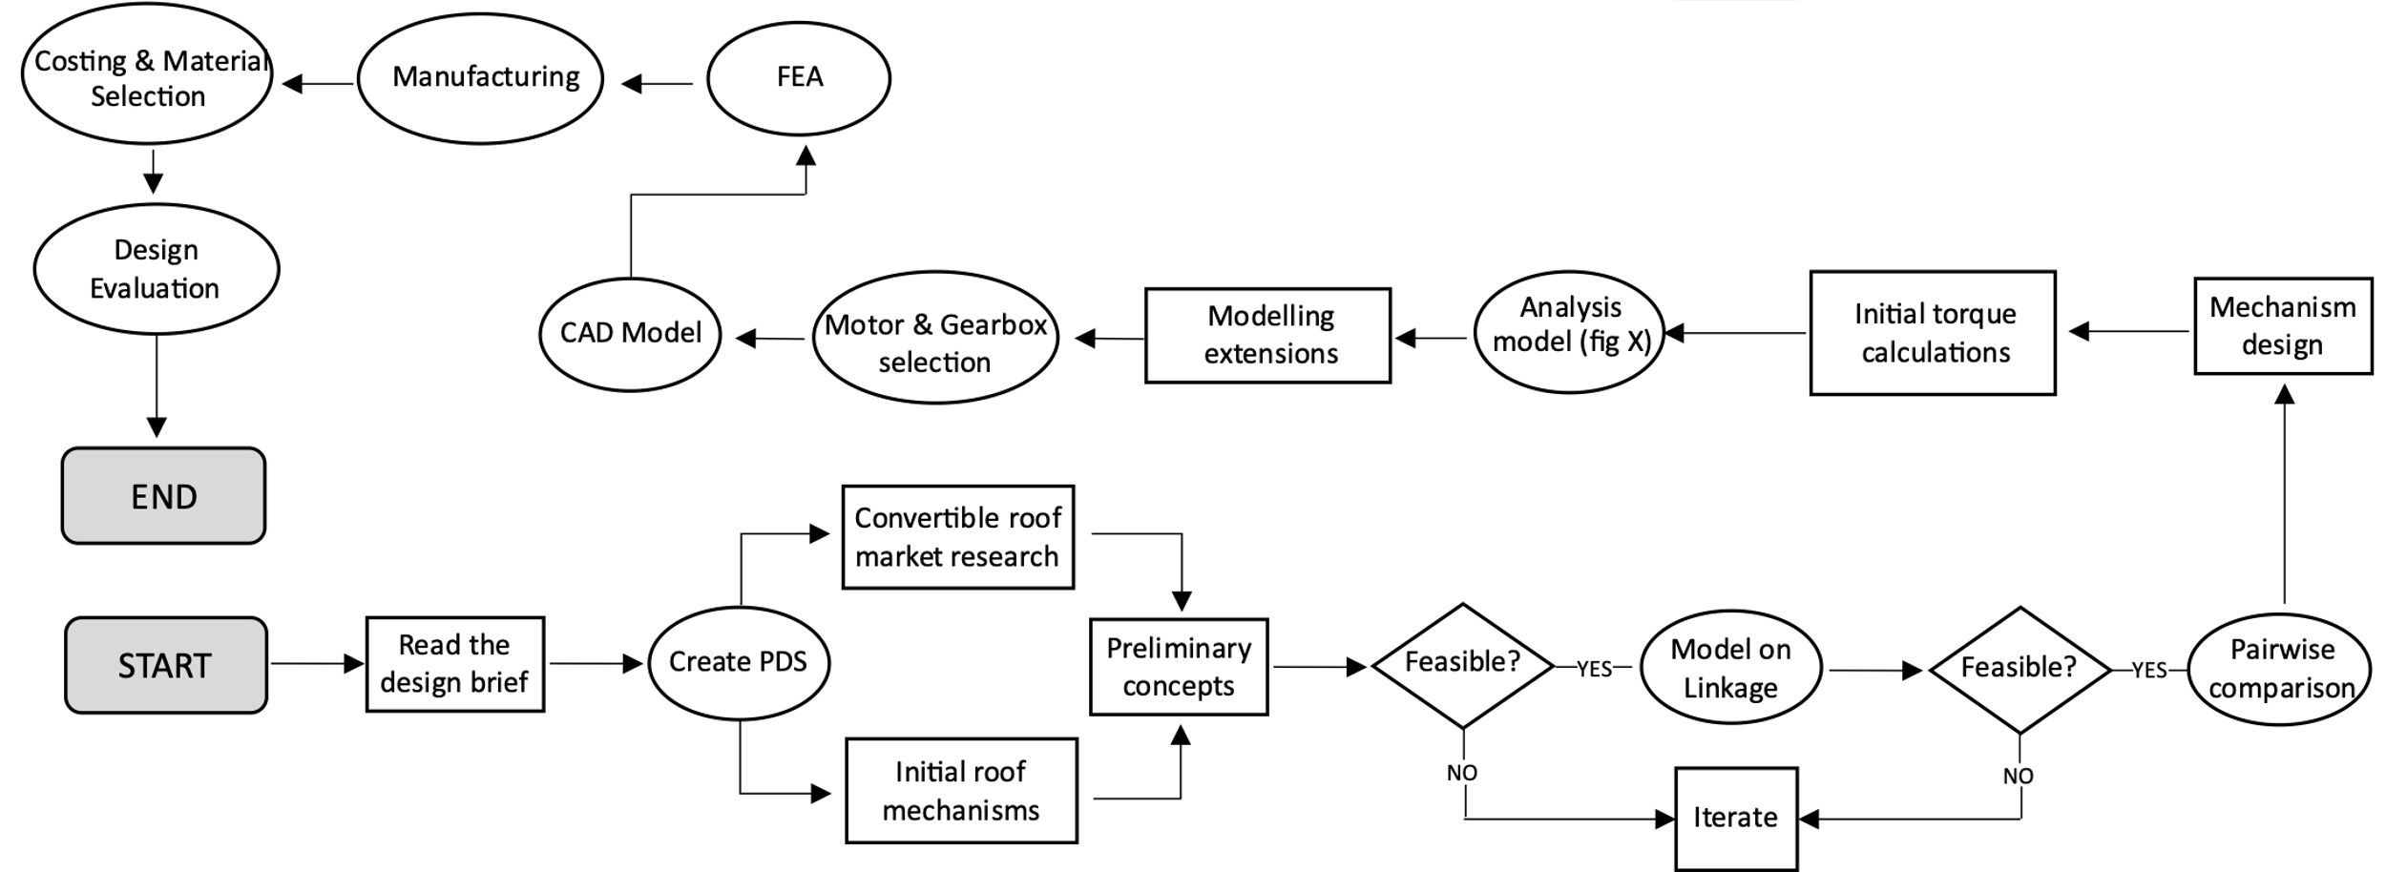

**Not in the scope of project:**

* Real-life sensor functionality with car based on its intended use.
* Real-life testing of retracting/deploying roof mechanism of Fiat 595 Abarth.
* Real-life testing of the chosen gear ratios and selected motor.
* Testing the life-cycle of the convertible Fiat 595 Abarth as it is not manufactured yet.
* Market research involving surveys to identify the needs of the required target market, not in the scope of the project due to time constraints.

## Key success criteria

* Come up with safety features that put the safety of the passengers and convertible roof mechanism as utmost priority.
* Design convertible roof report that contains similar features to the convertible Mini Cooper and remains within a similar price bracket to put it in direct competition with the convertible Mini.
* Conduct sufficient market research
* Aim to meet most, if not all of the requirements listed in the PDS of the report.
* Aim to stay in track with the recommended timelines given to us in the brief.
* Run iterations and constantly develop concepts and design decisions to produce the best possible ‘proof of design’ report. Important to do this throughout the report and not at the end of the report.

## Project assumptions

* **Assumption 1:** Group 1 acts as the engineering team at Abarth and the project is a ‘proof of design’ report made with the goal of taking the convertible roof idea forward into detailing and production for the Fiat 595 Abarth to put it in direct competition with the convertible Mini Cooper.
* **Assumption 2:** Us as the engineering team has access all components required to manufacture the convertible roof: Roof bracket, motor, chosen gears, chosen sensors, manufacturing methods.
* **Assumption 3:** Us as the engineering team have the budget to manufacture the components of the roof and conduct any required R&D throughout the design of the convertible roof mechanism.

# Project team & stakeholders

|  |  |  |
| --- | --- | --- |
| Role | Responsibility | Who |
| Market research and PDS requirements | Market research on convertible roof concepts and features of BMW Mini Cooper convertible. Constructing a PDS which provides guidance for chosen design decisions and concepts. | Darian |
| Manufacturing, material selection and costing | Details on manufacturing process of chosen component. Material selection process with appropriate justifications. Costing of chosen components need to manufacture the convertible roof mechanism. | Andhika, Darian |
| Drawings | Complete technical drawing of chosen component. Complete assembly drawing of the roof. Layout diagram showing gearbox arrangement. All drawings done on Fusion 360. | Andhika |
| Motor, gears, and gearbox | Selection of motor and gear ratio. Gearbox arrangement based on required system energy and torque. | Viral and Andhika |
| Modelling | Model of inverse pendulum, motor/gear combinations, gearbox efficiency, system energy use and COM. All calculations are coded on MATLAB and the graph outputs are explained in the report. | Viral |
| Iterations and design evaluation | Evaluation at the end of the report highlighting the success of the overall ‘proof of design’ report and a discussion of what could be done better. | All |
| Mechatronics | Selection of appropriate safety features and the sensors they use. Hardware schematic diagram of sensors. Arduino source code that uses the outputs from the sensors to signal the microcontroller. | Darian |

## Communication plan

|  |  |  |  |  |
| --- | --- | --- | --- | --- |
| Audience | Purpose & type of message/content | Communication channel | Frequency | Owner |
| Engineering Team | To track weekly progress with a Gantt chart and to ensure all members are kept up to date with concurrent work. | In person for majority group work, MS Teams for quick updates and weekly meetings. | 2x/week for group work and short online updates weekly. | Andhika, Viral, Darian |
| Project Supervisors (Professors) | To obtain feedback and constructive criticism throughout work to iterate work to conform to given feedback. | Submission gates & weekly in-person EngPrac lectures. | Weekly and dates given below in section 4. | Chris Snider |

# Project timeline

8-week project consisting of 5-day weeks – 40 days of official working time.

Stage-gate submission points:

Friday March 4th – Feedback stage gate 1

Monday March 21st – Feedback stage gate 2

**Technical Drawing Friday 29th April 12pm – Design FREEZE**

**Final report due Thursday 5th May**

# Risk register

|  |  |  |  |  |  |  |  |
| --- | --- | --- | --- | --- | --- | --- | --- |
| Ref. | Category | There is a risk that… | The consequence would be… | Likelihood  (1-5) | Severity  (1-5) | RF | Mitigation Action |
| 1 | Project | *Team member(s) are unable to carry out work because of COVID-19.* | *Fall behind on specific components, potentially delaying entire project.* | 1 | 3 | 3 | *Delegate work to others and try and work slightly ahead of schedule for extra leeway.* |
|  | Project | Not defining our priorities coherently | Design decisions made by group members can individually vary and a result in a broadly designed product | 3 | 4 | 12 | Ensure the brief is understood well and priorities clearly stated in the beginning of the report. |
|  | Project | Project schedule is not clearly defined or understood | Potentially not meet allocated deadlines | 4 | 3 | 12 | Hold scheduling meetings weekly so that the plan is understood, and the likelihood of missed task is reduced |
|  | Project | Project load not evenly distributed between group members | Overworking a team member and resulting in a lower quality outcome | 3 | 3 | 9 | Delegate deliverables to group members evenly at the start of the project and if it is uneven, some work can be handed over to a member with more time |
|  | Project | Insufficient understanding of the brief | Deviation from the scope of the project | 2 | 3 | 6 | Thoroughly read the brief individually and with the project team and note down key information |
|  | Project | Lack of communication between group members | individual tasks can deviate and possibly take forward an incorrect design decision | 3 | 4 | 12 | Weekly meetings to collate information on the tasks that have been completed within the last week |
|  | Project | Arbitrarily reducing task durations and run tasks in parallel | Not completing tasks to a high enough standard | 4 | 2 | 8 | Ensuring a method for project management is enforced and the time spent for tasks are sufficient |
|  | Project | Scope creep | spending more time on things that you don’t plan on considering | 3 | 2 | 6 | Document the project scope in the initial group meeting and ensure its authorised by the project manager |
|  | Project | Unplanned work that must be accommodated | Can have effects on other member’s work and time needs to be spent reconsidering the unplanned work | 4 | 3 | 12 | Discuss new work during weekly meetings and discuss a plan of action to try and minimise the setback |
|  | Project | Loss of documentation / failure of software | Hours of work lost and would need to be recompleted | 1 | 5 | 5 | Ensure that all documentation and work is frequently saved and if an auto-save feature is present, ensure its used. |
|  | Technical | Failure of mechanism due to excessive wind/car speeds | Danger to passengers and other road users | 1 | 5 | 5 | Sensors – airflow and hall effect sensor |
|  | Technical | Personal injury due to moving parts | Loss of fingers and legal action can be taken by customers | 1 | 5 | 5 | Sensors – capacitive proximity and casings |
|  | Technical | Lack of resources or supply chain issues | Delay in production and therefore not meeting the lead-times | 3 | 4 | 12 | Constant communication with suppliers so that any setback can be resolved immediately |
|  | Technical | Loose components | Unwanted oscillations, noise, and possible failure of system | 2 | 5 | 10 | dampers and fixings |
|  | Technical | *Gear could jam due to debris.* | *Roof failing mid-deploy could pose great consequences I.e. in extreme weathers* | 1 | 4 | 4 | *Ensure mechanism is covered and not fully exposed: no entrance points for debris into gearbox.* |
|  | Technical | Calculation/model errors | Roof failing and putting passenger at risk of danger | 2 | 5 | 10 | Stringent modelling testing to ensure that the model functions as it should |